Ejercicio 1 POO

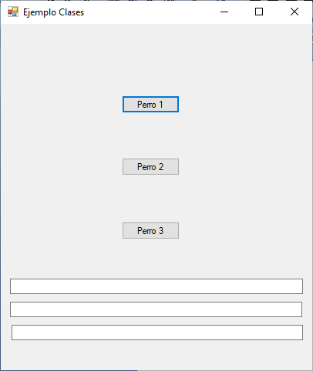

## Form 1

Public Class Form1

Private Sub Button1_Click(sender As Object, e As EventArgs) Handles Button1.Click

Dim perrito As Perro = New Perro()

perrito.nombre = "Mora"

perrito.raza = "Labrador"

perrito.altura = "0.70 cm"

Me.TxtResultado.Text = perrito.comer("Pollo")

Me.TxtResultado2.Text = perrito.ladrar("A veces")

End Sub

Private Sub Button2_Click(sender As Object, e As EventArgs) Handles Button2.Click

Dim perrito As Perro = New Perro()

perrito.nombre = "Pompon"

perrito.raza = "Caniche"

perrito.altura = "0.50 cm"

Me.TxtResultado.Text = perrito.comer("Carne Vaca")

Me.TxtResultado2.Text = perrito.ladrar("Siempre")

End Sub

Private Sub Button3_Click(sender As Object, e As EventArgs) Handles Button3.Click

Dim perrito As Perro = New Perro("Wendy", "Mini Pincher", "0.20 cm")

Me.TxtResultado3.Text = perrito.ladrar("Poco")

End Sub

End Class

## Clase PERRO

Public Class Perro

'propiedades

Public nombre As String

Public raza As String

Public altura As String

'constructor

Public Sub New()

End Sub

Public Sub New(nombre As String, raza As String, altura As String)

Me.nombre = nombre

Me.raza = raza

Me.altura = altura

End Sub

'metodos

Public Sub dormir()

End Sub

Public Function ladrar(ladra As String) As String

Return Me.nombre & ":es de raza:" & Me.raza & ":mide:" & Me.altura & ":y ladra:" & ladra

End Function

Public Function comer(carne As String) As String

Return Me.nombre & ":es de raza:" & Me.raza & ":mide:" & Me.altura & ":y comerá:" & carne

End Function

End Class